Wilson Football
Price: Approximately Rs 23,595
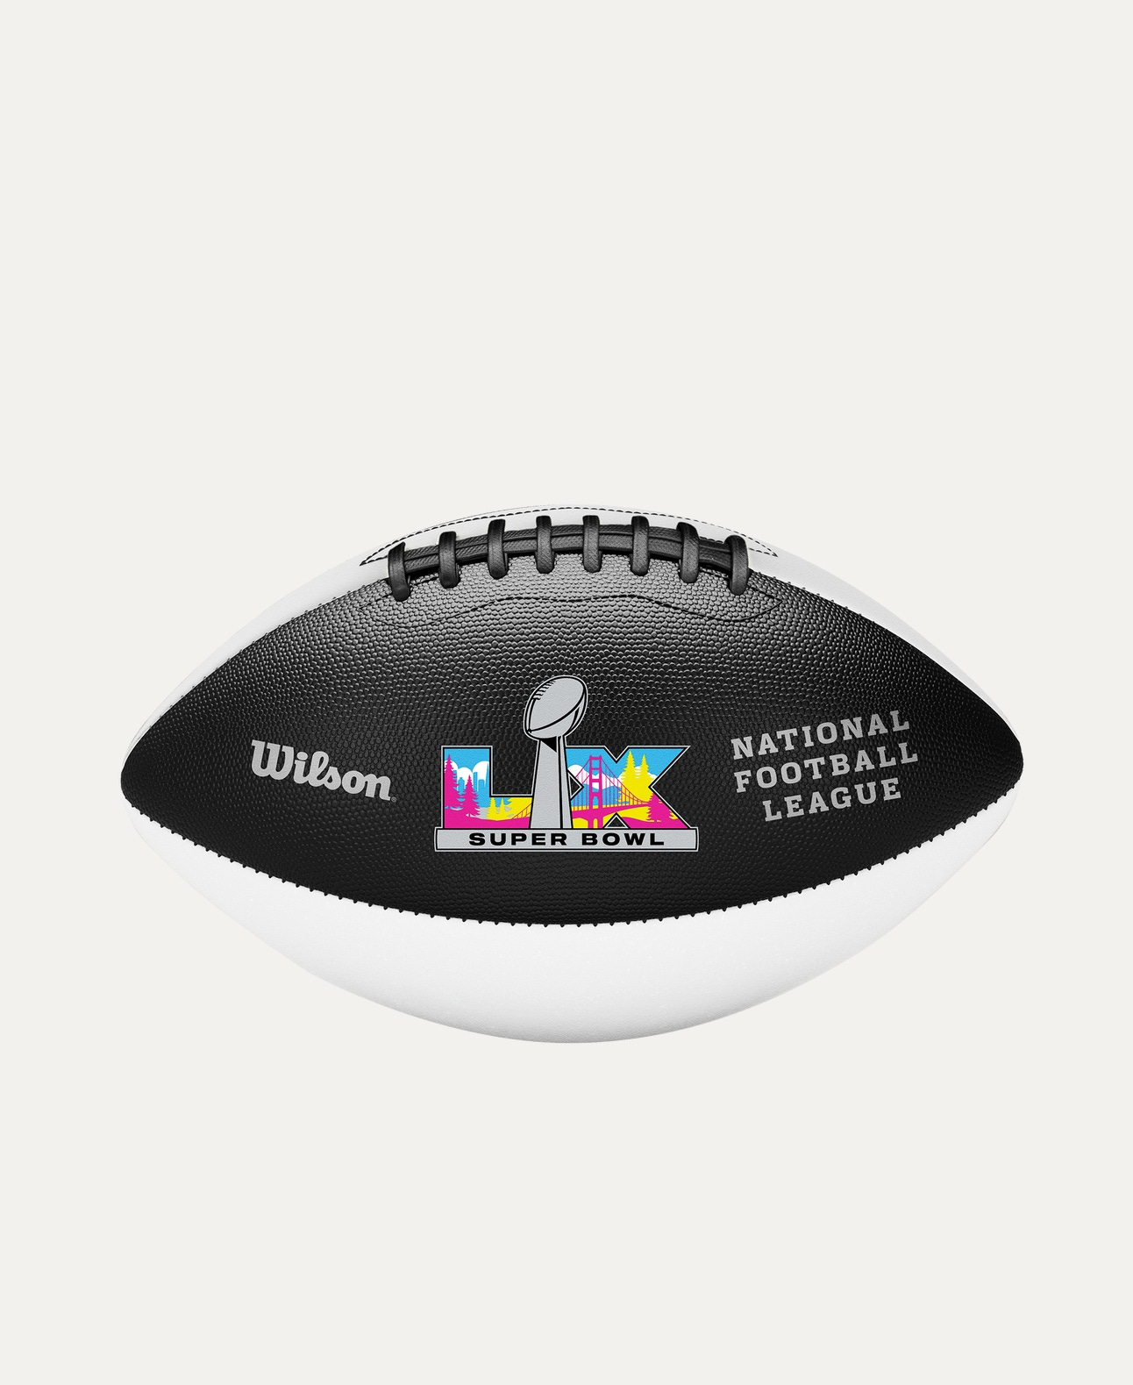
Introduction
The Wilson Football is designed for superior grip, control, and durability, making it a trusted choice for players at all levels. Known for its consistent performance, it is suitable for training, practice, and competitive games.

Product Overview
This Wilson Football features precision construction that delivers accurate throws, reliable grip, and excellent handling. Its balanced design supports smooth passing and controlled gameplay in all conditions.

About the Brand
Wilson is a globally recognized sports brand and an official supplier for professional football leagues. With decades of innovation and quality, Wilson footballs are trusted by athletes, schools, and sports organizations worldwide.

Key Features
- Excellent grip for better ball control
- Consistent shape and balance
- Strong stitching for long-lasting use
- Suitable for training and match play
- Professional-grade construction

Design & Build Quality
The football features a classic panel design with deep pebble texture for enhanced grip. Reinforced laces and precise stitching ensure reliable performance during intense play.

Storage & Capacity
Compact and easy to store, the football fits conveniently in sports bags or storage racks without losing its shape.

Material & Durability
Made from high-quality composite leather or rubber (model dependent), the Wilson Football is built to withstand regular use and tough playing conditions.

Ideal For
- Beginner to professional football players
- Training sessions and competitive matches
- Schools, colleges, and sports academies
- Indoor and outdoor play

Care Instructions
- Clean with a damp cloth after use
- Avoid over-inflation
- Store in a cool, dry place
- Keep away from sharp objects

Product Specifications
- Brand: Wilson
- Product Type: Football
- Material: Composite Leather / Rubber
- Size: Official and training sizes available
- Usage: Training & Match Play

Product Summary
The Wilson Football offers durability, grip, and consistent performance trusted by players worldwide. Whether for practice or competition, it is a reliable choice backed by Wilson’s professional sports expertise.

Thank you

